No. | Answer
a CaCO₃(s) + 2HCl(aq) → CaCl₂(aq) + H₂O(l) + CO₂(g)
b HCl(aq) + NaOH(aq) → NaCl(aq) + H₂O(l)
a n(HCl) initially = c × V = 1.020 × 40.00 × 10^{–3} = 4.080 × 10^{–2} mol
b n(NaOH) = c × V = 0.275 × 25.56 × 10^{–3} = 7.029 × 10^{–3} mol
c n(HCl) unreacted = n(NaOH) = 0.275 × 25.56 × 10^{–3} = 7.029 × 10^{–3} mol
d n(HCl)reacting = n(HCl) initially – n(HCl)unreacted
= 4.080 × 10^{–2} – 7.029 × 10^{–3} = 3.377 × 10^{–2} mol
e n(CaCO₃) = × n(HCl) reacting = × 3.377 × 10^{–2} = 1.689 mol
f m(CaCO₃) = n × M = × 3.377 × 10^{–2} × 100.09 = 1.690 g
g % CaCO₃ in marble = 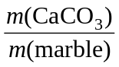 × 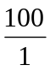 = 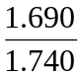 × = 97.1%
Solid sodium hydroxide absorbs water from the atmosphere. Solid samples may therefore be damp and therefore impure. Sodium hydroxide solutions react with carbon dioxide in the atmosphere, decreasing the concentration of the solution:
2NaOH(aq) + CO₂(g) → Na₂CO₃(aq) + H₂O(l)
 | CO₂ is an acidic oxide. It reacts with NaOH. If the CO₂ was not removed, more NaOH would be required for the titration, leading to an increased value for the unreacted HCl, and hence a decreased value for the CaCO₃ percentage.
Calcium carbonate is not soluble.
The carbonate ion is a weak base that gives an indistinct endpoint in a direct titration.
a This would dilute the acid. More would be required to react with the marble, giving an increased percentage for the carbonate.
b This would dilute the NaOH. More would be required to react with the HCl, giving an increased value for the unreacted HCl. This, in turn, would give a decreased value for the reacting HCl, and so a decreased percentage for the carbonate.
c This has no effect. Flasks should be rinsed with water.
n(CO₂) = 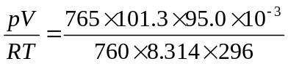 = 0.003 936 mol
n(CaCO₃) = n(CO₂) = 0.003 936 mol
m(CaCO₃) = n × M = 0.003 936 × 100.09 = 0.3940 g
% CaCO₃ in marble = × = 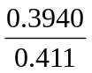 × = 95.9%
Small amounts of gas may have been lost in the collection process.
Some carbon dioxide may remain dissolved in the reaction solution.

